AIW FAQ
Category | AIW | Date | 2025/09/02
Keyword | AIW-169/EWM-W179/AIW-163,Linux Ubuntu 22.04.4(6.5.0-27),WoWLAN, Realtek chipset solution,ARK-1250

- Question:
How to enable WoWLAN feature on Linux Ubuntu 22.04 when working with AIW-169/EWM-W179/AIW-163 modules?

- Instructions :
Step 1
Please download proprietary WiFi driver package by model below
AIW-169(rtl8852CE)_WiFi_linux_v1.19.4.4-0-g0b81da37b.20230906_
EWM-W179_AIW-163(rtl8852BE)_WiFi_linux_v1.19.7.0-18-gee24b6aac.20230614

Step 2
Decompress files and modify WoWLAN related configs in Makefile and save it
- CONFIG_WOWLAN=y
CONFIG_WAKEUP_TYPE=0xf
CONFIG_WOW_LPS_MODE=default
CONFIG_GPIO_WAKEUP=n
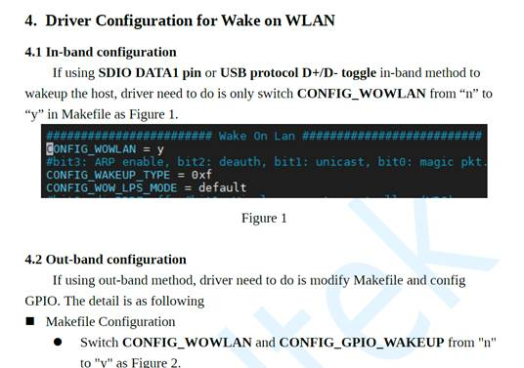
Note: Due to WiFi communication interface belows PCIE, it must refer to In-band configraiton and please make sure disable “CONFIG_GPIO_WAKEUP” in Makefile

Step 3
Compile wlan driver and load driver “.ko” file manually
Note: if you are not familiar with driver compiling,please refer driver bring up SOP in our FAQ knowledge base
Step 4
Input “iw” command to check WOWLAN feature status
- sudo iw phy0 wowlan show
Prompt message must return blow:
WoWLAN is enabled:
* wake up on special any trigger
Note: if WoWLAN feature is not enable, please input following command
- sudo iw phy0 wowlan enable any

Step 5
Execute Third Party utility and wake up your device by sending magic packet on resume from suspending state to Resume
<example>
